REPORT z.  
PARAMETERS:empno(4) TYPE n,  
          ename(10) TYPE c.  
AT SELECTION-SCREEN OUTPUT.  
LOOP AT SCREEN.  
IF SCREEN-NAME = 'ENAME'.  
    SCREEN-INVISIBLE = 1.  
    MODIFY SCREEN.  
ENDIF.  
ENDLOOP.  
START-OF-SELECTION.  
WRITE :/ 'Ename is :', ename.  
WRITE :/ 'Empno is :', empno.

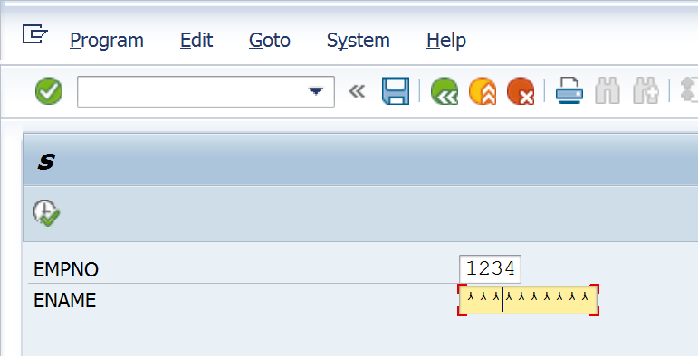

Data Entry is allowed in the above field. This works like a password field. You can type but cannot see what has been typed.

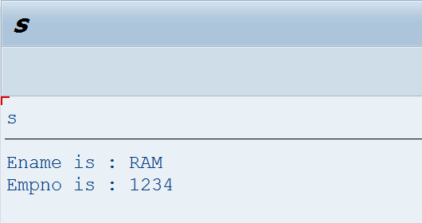

If the above is changed to SCREEN-INVISIBLE = 0, you can see the data entered.

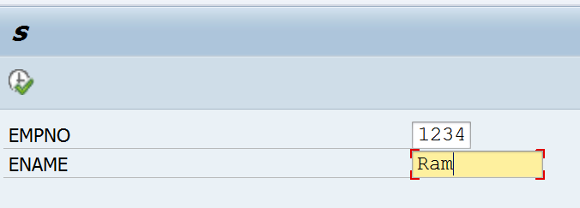

**Note: There is nothing as SCREEN-VISIBLE = 0 OR SCREEN-VISIBLE = 1.**

